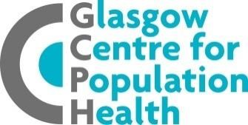  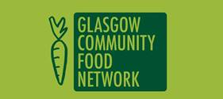 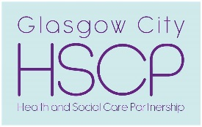

**Glasgow City Food Plan - What will it mean for your business?**

**2-3.30pm Tuesday 8th December 2020**

**Via Zoom**

25th November 2020

Dear Glasgow Business Owner,

You may have heard about Glasgow City Food Plan currently under consultation. So far we have involved over 80 organisations to develop the proposed plan, and we would now like to hear directly from Glasgow based businesses. Whether your business is big or small, is involved directly in food growing/ production/selling food/catering or just serves food for staff or at events, we would love to hear from you. Food is everybody’s business and your opinion matters!

The GCFP is a route map for the whole city and has been produced by people from the NHS, the City Council and the Community Food sector working together. The vision of the GCFP is that everyone in the city can eat healthy, affordable, culturally appropriate, good food no matter where they live, their income or personal circumstances. By good food we mean food that is accessible, affordable, tasty and healthy, that is good for the environment and good for those that work in the food industry.

We have already heard from some businesses/organisations, but we want to make sure the plan reflects the needs and views of as many local businesses as possible. That is why we are inviting people from the business community to join in a conversation about the Glasgow City Food Plan, which includes the following 6 themes:

1. **Fair food for all (food poverty)**
2. **Community food**
3. **Food procurement and catering**
4. **Food economy**
5. **Environment and food waste**
6. **Children and young people**

During the event you will hear how your business could contribute to and benefit from more sustainable food system in Glasgow. You will also find out what COP26 Climate Change conference might mean for your business and get a chance to make your views heard.

We would love to hear from people who have not yet engaged with the consultation. **If you have already attended working groups or other events linked to GCFP, we would ask you invite a colleague to attend!**

We hope that you/friend/colleague are able to participate. **You can register for the event [here](https://uofglasgow.zoom.us/meeting/register/tJMrcOCqrDgrE9QmvAFR2oFmKAik3WKUAZOS) at your earliest convenience.  Once you have registered, you will receive an automated reply with joining instructions which includes your unique link to join which should not be shared with anyone else.**

You can read the consultation paper and/or respond to the consultation [here](https://www.glasgowconsult.co.uk/KMS/dmart.aspx?strTab=PublicDMartCurrent&NoIP=1). More information about the GCFP can be found [here](http://goodfoodforall.co.uk/home/glasgow-city-food-plan).

Kind Regards,

Abi, Elizabeth, Jill, Louise, Riikka, Siobhan

**Glasgow City Food Plan Team**